Incident Response - P1

Assignment: Practical 1

Subject Name: IRDF

Student Name: Aastha Thakker

Enrollment Number: 250100302204

Pair Partner Name: Kunsh Dhwan

Date: 21-01-2026

Installation of Sysmon

System Monitor (Sysmon) is a Windows system service and device driver that remains resident across system reboots to monitor and log system activity to the Windows event log. Part of the Microsoft Sysinternals suite, it provides detailed information about process creations, network connections, and changes to file creation time. Unlike standard Windows event logs, Sysmon offers a much deeper level of granularity, capturing the "who, what, where, and how" of system events.

Installing Sysmon is straightforward and involves using the command line with administrative privileges.
- Download: Grab the Sysmon zip file from the official Microsoft Sysinternals website.
- Extract: Unzip the folder to a directory (e.g., C:\Sysmon).
- Find a Config: While you can run Sysmon with default settings, it is highly recommended to use a configuration file (like SwiftOnSecurity’s config) to filter out noise and focus on high-value events.
- Execute: Open PowerShell or Command Prompt as an Administrator and run:
sysmon64.exe -i sysmonconfig.xml -accepteula
(Note: Replace sysmonconfig.xml with the path to your specific config file.)
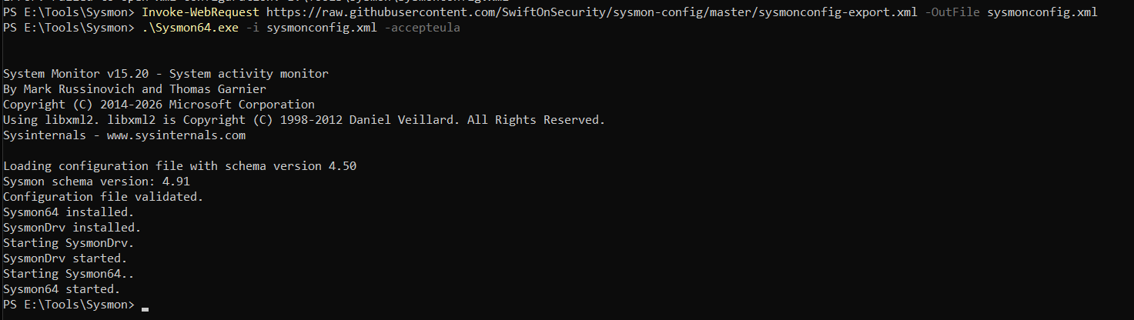
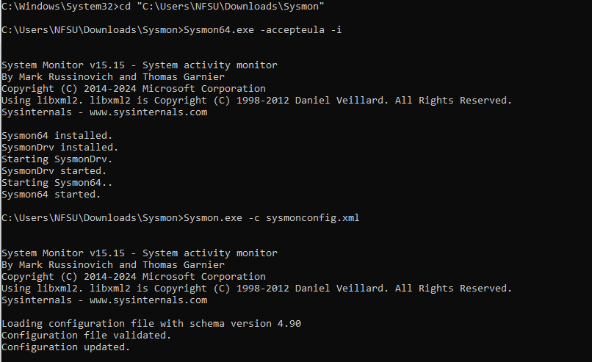

Activity 1: DNS query

- Performed action: A DNS query was initiated for the domain https://www.google.com/search?q=google.com.
- Timestamp: 21-01-2026 15:59:58 (Logged Time) / 2026-01-21 10:29:56.515 (UtcTime).
- Sysmon Event ID: 22
- Evidence:

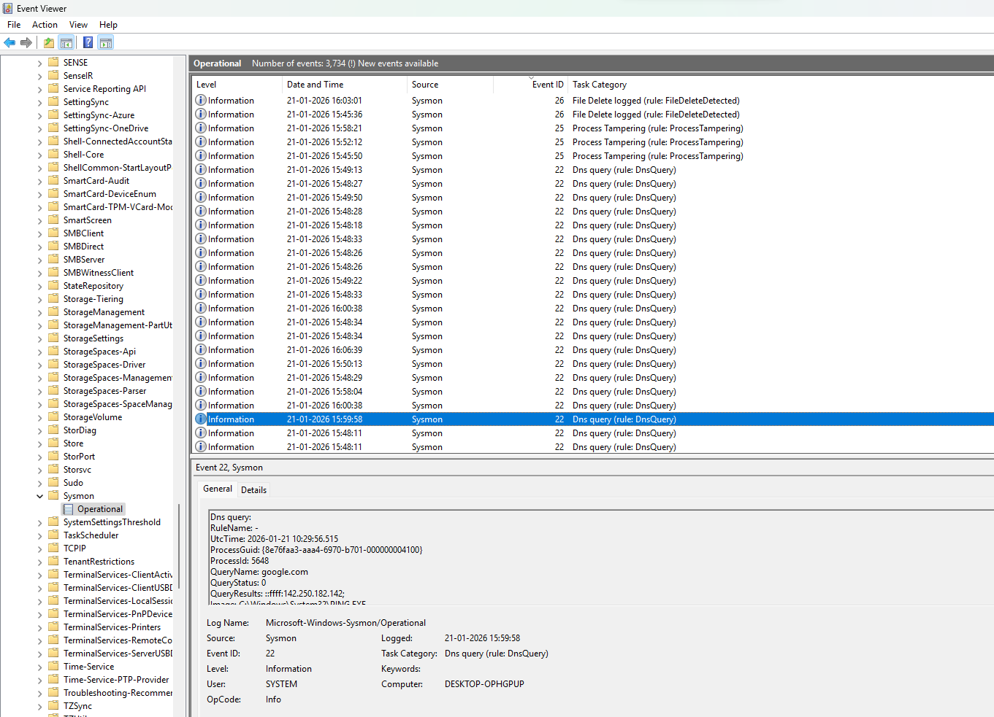

Observation: The system successfully resolved the domain "https://www.google.com/search?q=google.com" to the IP address 142.250.182.142. The event was recorded under the Microsoft-Windows-Sysmon/Operational log by the SYSTEM user on the computer DESKTOP-OPHGPUP.

Activity 2: CMD command

- Performed action: The Sysmon configuration state was changed/updated via the command line.
- Timestamp: 21-01-2026 15:43:47 (Logged Time) / 2026-01-21 10:13:47.226 (UtcTime).
- Sysmon Event ID: 16
- Evidence:
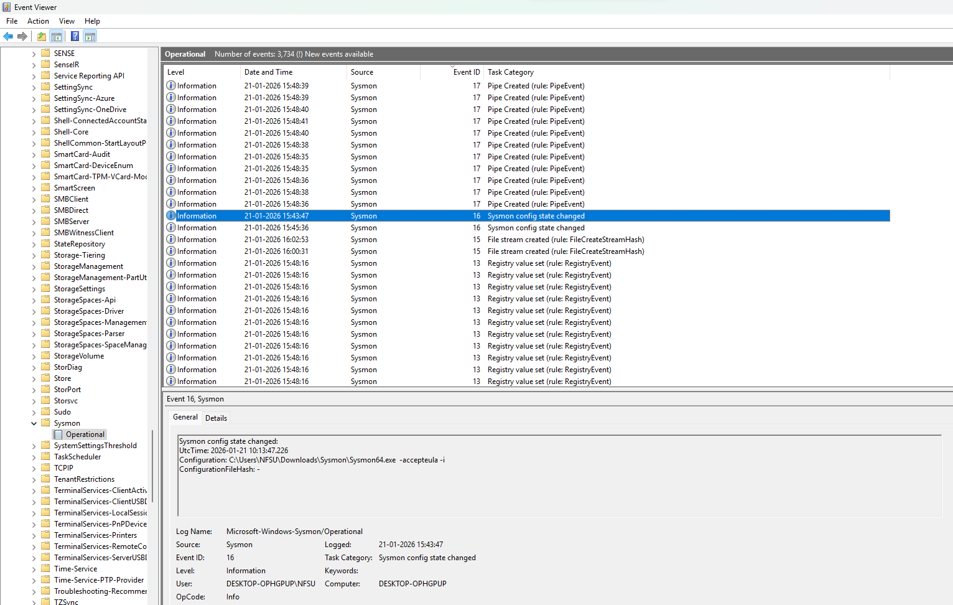

- Observation: A user named NFSU manually updated or reinstalled the Sysmon configuration using the -i (install/update) and -accepteula flags. This indicates an administrative action to modify how Sysmon monitors the system.

Activity 3: Opening an application

- Performed action: A registry value was set/modified by the Google Chrome application.
- Timestamp: 21-01-2026 16:13:45 (Logged Time) / 2026-01-21 10:43:45.519 (UtcTime).
- Sysmon Event ID: 13
- Evidence:
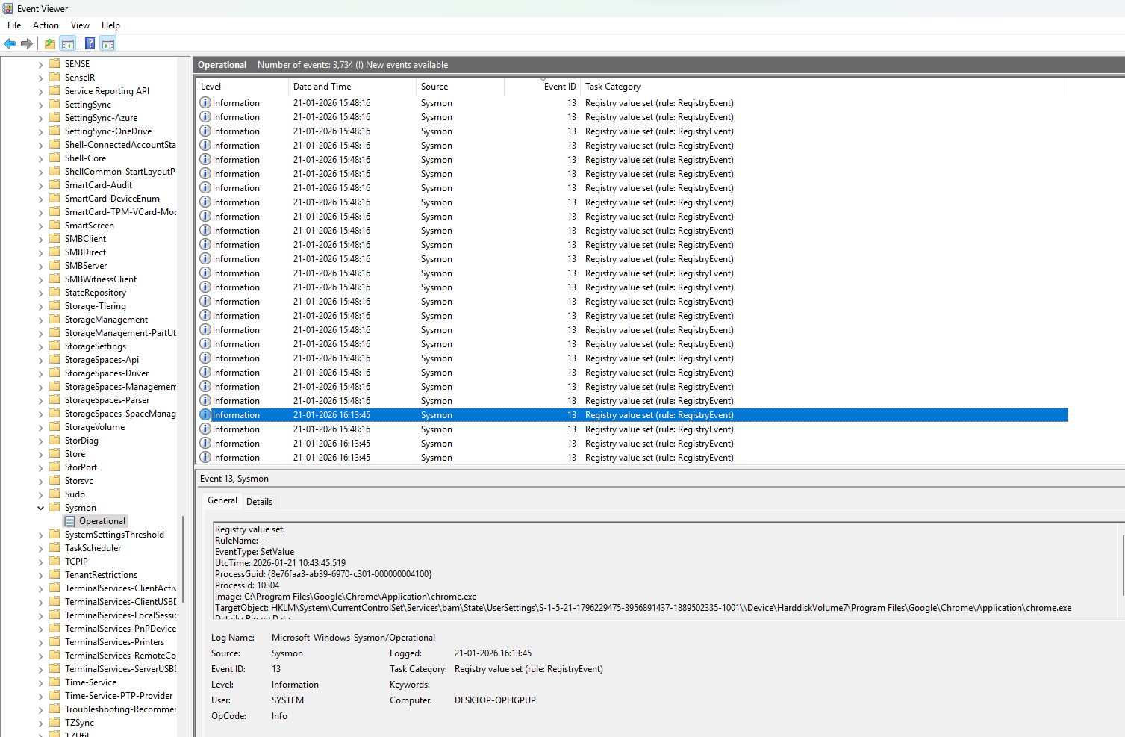

- Observation: The Google Chrome process modified a registry key within the Background Activity Moderator (BAM) settings. This is a common system behavior where Windows tracks executable usage for power management, but monitoring it helps identify unauthorized persistence attempts by malware.

Activity 4: File created

- Performed action: A new file was created on the system by the Microsoft Word application.
- Timestamp: 21-01-2026 15:54:33 (Logged Time) / 2026-01-21 10:24:33.637 (UtcTime).
- Sysmon Event ID: 11
- Evidence:
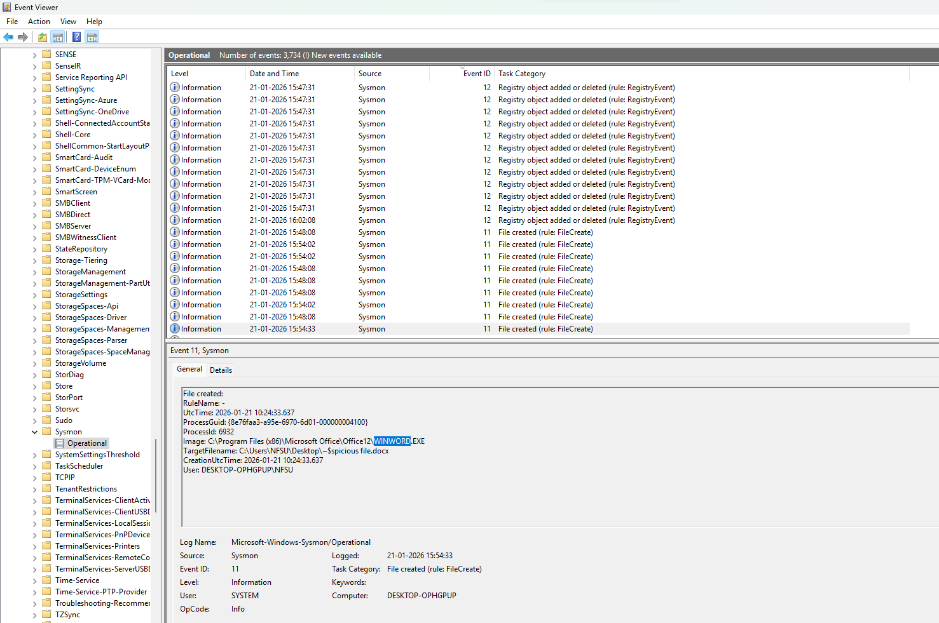

- Observation: The WINWORD.EXE process created a temporary owner file on the desktop. This is standard behavior when a Word document named "picious file.docx" is opened or edited, as Office creates these hidden temporary files (starting with ~$) to manage file locking and recovery.

Activity 5: Scheduled Activity

- Performed action: A new process was started to create a scheduled task for persistence.
- Timestamp: 27-01-2026 11:14:32 (Logged Time) / 2026-01-27 05:44:32.465 (UtcTime).
- Sysmon Event ID: 1 (Process created)
- Evidence:
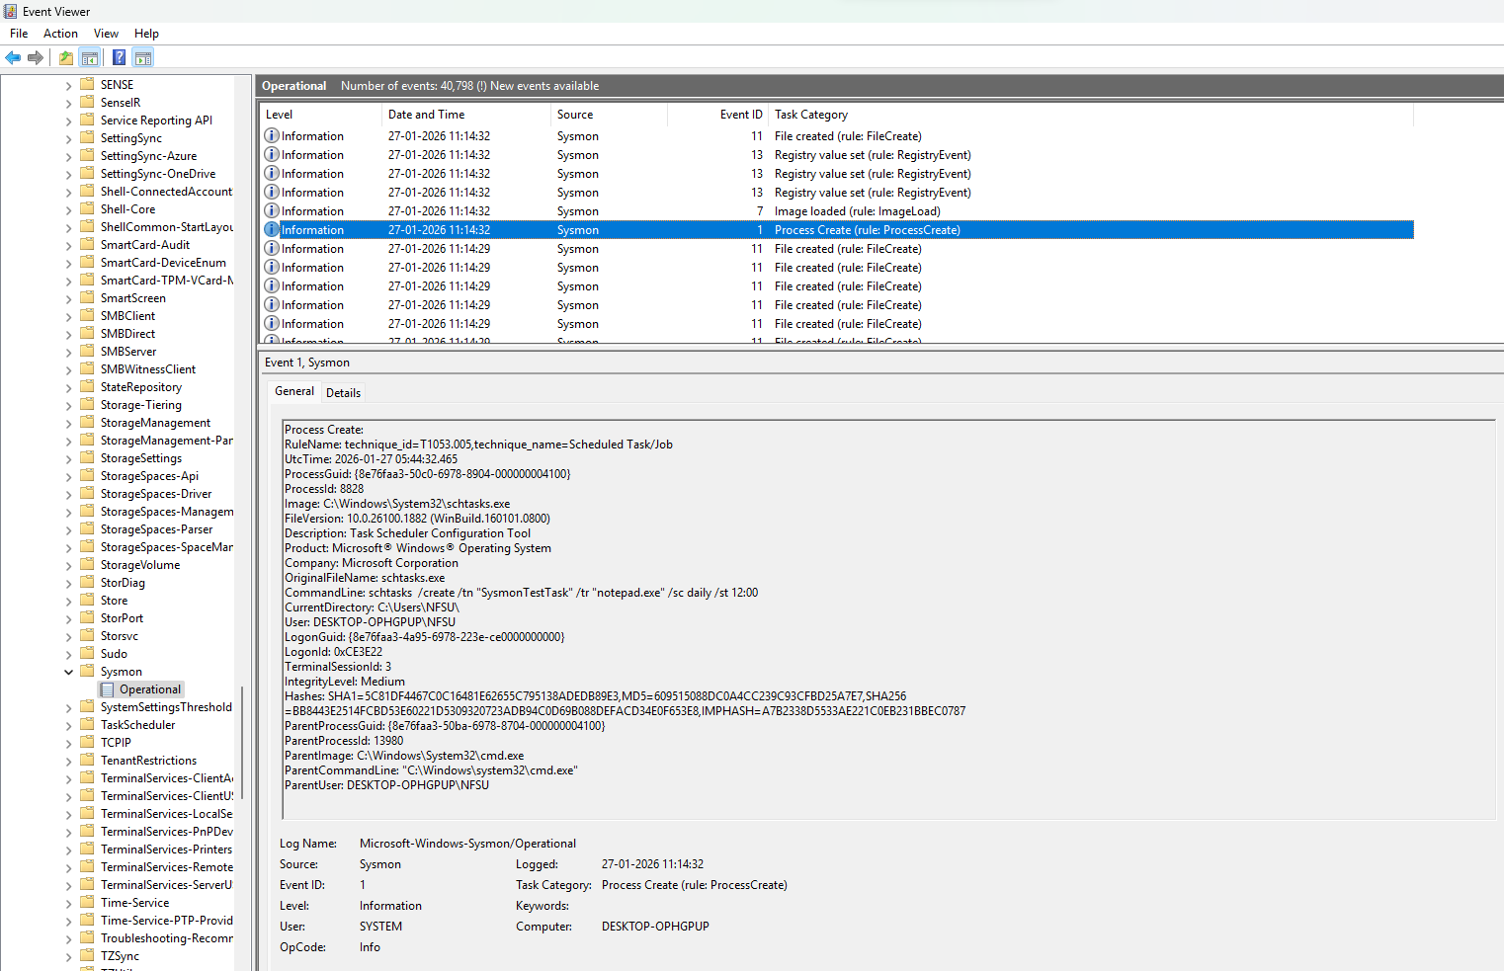

- Observation: The user NFSU executed a command through the Command Prompt (cmd.exe) to create a new scheduled task named "SysmonTestTask". This task is designed to trigger notepad.exe daily at 12:00. This is a classic example of a "Persistence" technique, where a program is set to run automatically at a specific time or interval.

Conclusion:

Activity No. | Performed Action | Sysmon Event ID | Timestamp (Logged) | Key Evidence
1 | DNS Query Resolution | 22 | 21-01-2026 15:59:58 | Resolved google.com to 142.250.182.142.
2 | Sysmon Config Change | 16 | 21-01-2026 15:43:47 | Executed sysmon64.exe -i to update configuration.
3 | Registry Value Modification | 13 | 21-01-2026 16:13:45 | chrome.exe modified Background Activity Moderator (BAM) settings.
4 | File Creation | 11 | 21-01-2026 15:54:33 | WINWORD.EXE created a temporary file ~$picious file.docx.
5 | Process Creation (Persistence) | 1 | 27-01-2026 11:14:32 | schtasks.exe created a task named SysmonTestTask via cmd.exe.

